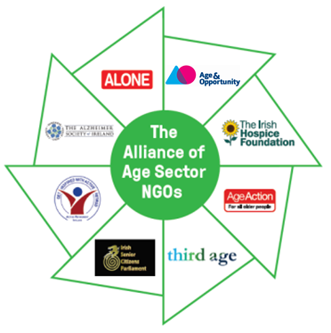

Recruitment Pack

Co-ordinator of the
Alliance of Age Sector NGOs

February 2020

F

Contents

About the Alliance of Age Sector NGOs 3

Advertisement 4

Person Specification 6

Job Description 7

How to Apply 9

The Alliance of Age Sector NGOs: Annual Statement 2018 10

About the Alliance of Age Sector NGOs

Eight NGOs working in the ageing sector in Ireland have formed The Alliance of Age Sector NGOs to address the key issues facing older people and to progress implementation of the National Positive Ageing Strategy. The partnership is committed to communicating with the wider ageing stakeholder group and work closely with the Department of Health and other government departments.

These organisations are Active Retirement Ireland, Age Action, Age & Opportunity, ALONE, Alzheimer Society of Ireland, The Irish Hospice Foundation, the Irish Senior Citizen’s Parliament, and Third Age Ireland.

The Mission of the Alliance

- To bring together in one nationwide and multi-disciplinary coalition representatives of non-governmental organizations engaged in the promotion of active ageing and advocacy on behalf of older people.
- To encourage practical exchange and cooperation among the diverse NGOs engaged and interested in active ageing throughout Ireland.
- To foster active ageing research, scholarship, education, training and advocacy within inter-governmental and governmental institutions as well as in academic and other public organisations and agencies.
- To enhance the collective role of the Alliance members through cooperation among affiliated organizations with regard to pro-grams, research projects, publications, and other activities of mutual interest.
- To assist all branches of Government, and the Department of Health in particular, in the identification of existing and emerging issues around ageing in Ireland, in the initiation of research studies and recommendations for action, and in supplying technical assistance in specific areas of Alliance competence.

Advertisement
Eight NGOs working in the ageing sector in Ireland have formed The Alliance of Age Sector NGOs to address the key issues facing older people and to progress implementation of the National Positive Ageing Strategy. The partnership is committed to communicating with the wider ageing stakeholder group and work closely with the Department of Health and other government departments.
These organisations are Active Retirement Ireland, Age Action, Age & Opportunity, ALONE, Alzheimer Society of Ireland, The Irish Hospice Foundation, the Irish Senior Citizen’s Parliament, and Third Age Ireland.

We now wish to recruit a
Co-ordinator of The Alliance of Age Sector NGOs
to fully leverage The Alliance’s capacity to ensure the voice of older people is heard in 2020.

Applicants must have:
- A strong knowledge of and interest in Ireland’s ageing landscape, political environment, policies and structures and
- A minimum of three years’ experience in project management / co-ordination role.
- An ability to analyse information quickly and communicate in a concise and articulate manner.
- Excellent written and oral communication skills.

A degree level qualification in a relevant field is desirable but not essential.

This position presents a great opportunity to influence policy in the ageing sector. It is a part-time position with flexible working over a 21 hour week.
Specifics of the working pattern will be agreed with the successful candidate.

This position involves a specified purpose three year contract.
Salary: €45,000 pro-rata based on 35 hour week.

Location: The post holder will be based in ALONE offices, Dublin.

A full job description and person specification is available on www.ageandopportunity.ie and www.alone.ie.

ALONE will be the host organisation and will provide support, working space and ensure all HR policies and procedures are in place.

Please submit your CV and cover letter, outlining how you meet the criteria in the person specification, to:

Alliance of Age Sector NGO recruitment
c/o Margaret Roe,
HR Manager,
Age & Opportunity,
St. Patrick’s Building,
Marino Institute of Education,
Griffith Avenue, Dublin 9
(or Margaret.Roe@ageandopportunity.ie) by 12noon on Tuesday the 18th of February.

All member of the Alliance of Age Sector NGOs are Equal Opportunities Employers.

Person Specification

Co-ordinator of The Alliance of Age Sector NGOs

This person specification sets out the various criteria which are essential for the post and by which we will assess your application.

Experience
- A strong knowledge of and interest in Ireland’s ageing landscape, political environment, policies and structures,
- A minimum of 3 years’ experience in a co-ordination / project management role.

Skills

- Strong leadership and communication skills.
- An ability to analyse information quickly and communicate in a concise and articulate manner.
- Excellent written and oral communication skills.
- Strong project management and organisation skills, as well as attention to detail.
- A team player with good interpersonal and social skills and the ability to engage with a range of people.
- High level computer literacy and competency in Word, Excel and PowerPoint.

A relevant third-level qualification in a relevant field is desirable but not essential.

Job Description

Co-ordinator of The Alliance of Age Sector NGOs

Position: Part-time (flexible working 21 hours per week)

Reporting to: Appointed line manager in ALONE. Accountable for the implementation of annual work plans to the Chair of the Alliance of Age Sector NGOs.
Location: The positon will be based in the offices of ALONE, in Dublin. (ALONE are one of the members of the Alliance of Age Sector NGOs).

Tasks and Responsibilities:
- Report to line manager in ALONE.
- Be accountable to the Chair of the Alliance to achieve agreed outcomes 2020-2022.
- Organise Alliance meetings and prepare the meeting pack for the Alliance meetings, and meetings of the Public Affairs Subgroup, and provide administration support to the alliance generally.
- Assist in the development and co-ordination of new projects, initiatives and campaigns.
- Support the Alliance of Age Sector NGOs to achieve its aims, including, but not limited to:
  - Securing political commitment to enhanced strategies for older people.
  - Obtaining a coherent and united voice for older people.
  - Achieving specific agreement in the post-election negotiations and Programme for Government on a whole-of-Government approach to ageing in Ireland.
  - Building on the work of the Homecare Coalition in regard to the model, costs and statutory underpinning of homecare.
  - Pre-budget submissions.
- Ensure the Alliance is run smoothly and meeting its commitments and goals.
- Manage events as agreed in the yearly action plan.
- Support the Alliance members to develop papers and actions to further the NPAS implementation and establish and maintain strong links with the NPAS Stakeholder Forum.
- Support the Alliance to work with both statutory and voluntary organisations and older people themselves to develop solutions to those challenges through the National Positive Ageing Strategy.
- Assist the Alliance to develop ways to work relevant Government departments and agencies.
- Attend to policy issues within the areas of the action plan as agreed by the Alliance.
- Facilitate meetings and build relationships as required.
- Provide direction to and support the Public Affairs Committee (and any other working group of the Alliance) on behalf of the Alliance and report back to the Alliance on their work.
- Respond to incoming enquiries and providing an information service on all aspects of the work of the Alliance of Age Sector NGOs.
- Administration of web and social media content as required in conjunction with the Public Affairs Sub-group.
- Take responsibility for operational and office administration issues such as office logistics, filing, file management, archiving data, budget administration and record keeping and invoicing.
- Identify sources of funding and prepare funding applications.
- Promote and represent the Alliance of Age Sector NGOS at events if requested by the Chair.
- Commit to the purpose of the Alliance of Age Sector NGOs.
- Undertake any other tasks as will from time to time be requested.

Responsibilities as an employee of ALONE
- Ensure adherence to defined quality, standards and policies on all projects undertaken.
- Follow the procedures outlined in ALONE’s Employee Handbook, Policies and Procedures Manual and Safety Statement and work within the values, policies and procedures of the organisation and in the context of current legislation and regulations.
- Participate in regular supervision with your line manager.
- Report any area of concern to your line manager in a timely manner.
- Show reasonable flexibility in relation to hours of attendance to meet the needs of the work. Work during unsocial hours may be required.
- Have a flexible approach to the work in response to organisational change, development and review of best practice.
- Participate in and engage with a performance management programme.
- Identify training needs with your line manager and participate in training opportunities appropriate to the role.
- Be vigilant to any health, safety and welfare risks in the workplace and bring any concerns to the attention of your line manager or Health and Safety representative.
- Operate within agreed budgets seeking authorisation for expenditure and to be accountable for such expenditure authorised, and to ensure the appropriate coding of expenses.
- Provide written reports as per deadlines requested.

How to Apply

Please submit your CV and cover letter, outlining how you meet the criteria in the person specification, to:

Alliance of Age Sector NGOs recruitment
c/o Margaret Roe,
HR Manager,
Age & Opportunity,
St. Patrick’s Building,
Marino Institute of Education,
Griffith Avenue, Dublin 9
(or Margaret.Roe@ageandopportunity.ie) by 12noon on Tuesday the 18th of February.

All member of the Alliance of Age Sector NGOs are Equal Opportunities Employers.

The Alliance of Age Sector NGOs
First Annual Statement
2018

F

The Alliance of Age Sector NGOs: Annual Statement

Context
Eight NGOs working in the ageing sector in Ireland have formed The Alliance of Age Sector NGOs to address the key issues facing older people and to progress implementation of NPAS. The partnership is committed to communicating with the wider ageing stakeholder group and work closely with the Department of Health and other government departments.
These organisations are:

Age Action  Active Retirement Ireland  Age & Opportunity  ALONE | Alzheimer Society of Ireland  The Irish Hospice Foundation  The Irish Senior Citizens’ Parliament  Third Age Ireland

It’s a long time coming…

More than ten years ago, the National Council on Ageing and Older People stated:
As a society….unless we understand and engage with the issues of ageing and the issues faced by older people, we will not create – or eventually enjoy – an age friendly society. (National Council on Ageing and Older People 2005, an Age Friendly Society: A Position Statement)

This statement remains true today yet, we do not have an age friendly society. The National Positive Ageing Strategy (NPAS) was published in 2013 and was a very positive statement of intent towards the creation of an age friendly society. It states four goals, has two ‘cross-cutting’ objectives and 23 objectives under the goals. All areas of life and consequently of government, relevant to older people were reflected in the broad range of objectives included in the NPAS. Five years on from the publication of NPAS, there has been little progress.
Through the work of the Alliance, we have identified four priority issues from NPAS that need to be addressed to achieve an Age Friendly society:
- Participation, Health and Well-being;
- Living at Home: Social Supports and Housing;
- Income and Security;
- Tackling Ageism

We believe that, to date, policy on ageing has dealt almost exclusively with health and social care issues. The aim should be to empower older people to be part of the solutions to problems that they, and their communities, face – promoting active ageing through an ethos that prizes equality, not charity – and aiming to include older people in need of care in the life of their communities to the maximum extent possible.

We must ensure that all older people can continue to be engaged citizens. Furthermore, we share concerns for groups that are at risk of increased exclusion or marginalisation at advanced age. We seek services and opportunities that aim to keep people connected to their communities and that promote participation and wellbeing. We share a conviction that responding to the challenges and opportunities of population ageing requires a cultural shift in the way we imagine ageing and in the way we plan and implement policies and services, for citizens of all ages.

The Mission of the Alliance
- To bring representatives of non-governmental organisations engaged in the promotion of active ageing and advocacy on behalf of older people, together in one nationwide, multi-disciplinary coalition
- To encourage practical exchange and cooperation among the diverse NGOs engaged and interested in active ageing throughout Ireland.
- To foster active ageing research, scholarship, education, training and advocacy within inter-governmental and governmental institutions as well as in academic and other public organisations and agencies.
- To enhance the collective role of the Alliance members through cooperation among affiliated organisations with regard to awareness programmes, research projects, publications and other activities of mutual interest.
- To assist all branches of Government, and the Department of Health in particular, in the identification of existing and emerging issues around ageing in Ireland, in the initiation of research studies and recommendations for action, and in supplying technical assistance in specific areas of Alliance competence.

As NGOs, we work independently within our own organisations but collectively through the Alliance of Age Sector NGOs. Partnership work between NGOs requires a lot of commitment and resources and the current CEOs and boards of the eight NGOs are committed to this way of working.

Although we acknowledge progress on research activities, we are truly concerned about the slow pace of implementation of the National Positive Ageing Strategy (NPAS); in particular
- that current plans are not robust or transparent enough;
- that they do not provide for sufficient input by older people and their representatives;
- that there is unclear leadership and ownership.
We believe the NPAS needs robust implementation measures across the full range of Departments involved, underpinned by political and administrative leadership – to ensure there is consistency between policies on services for older people and their implementation.
It is with this in mind that the Alliance is focusing on implementation of the NPAS in 2018-19.

Mission progress 2017/8

Our agenda | Achievements
To focus on strengthening this alliance of members and partnership working between the eight partner organisations. This Alliance is relatively new but it builds on many years of partnership and shared common interests. | The Alliance met almost monthly over 2017 and 2018 and extended its membership from six to eight organisations by 2018. At present, we are a voluntary alliance comprised of members who choose to work in partnership with each other. We are building on the work of Older and Bolder and of the collaborative work of the Active Ageing Partnership funded by Atlantic Philanthropies in 2014/17.  In our briefing paper for 2017, four priority areas were agreed on by the Alliance as the focus of our work:  - Participation, Health and Well-being;  - Living at Home: Social Supports and Housing;  - Income and Security;  - Tackling Ageism  An agreed Terms of Reference and Memorandum of Understanding has been signed by all collaborating organisations based on the above priorities. We have been successful in receiving two grants, one from Community Foundation of Ireland and the other from Atlantic Philanthropies for the above work.
To focus on implementation - by supporting and challenging the Department of Health to create implementation structures for NPAS  in 2018/19. | The Alliance supports the Department of Health by designing a process for the 2018 National Stakeholder Forum and meeting with the key officials to plan the day and provide follow up.
To focus on progress and raising awareness on implementation of NPAS through media campaigns and by researching and preparing a scorecard as an independent NGO assessment of progress against the NPAS. | A position paper on NPAS implementation was produced by the Alliance. This is now available to members in a draft format. A process has been designed for this work. We have met with the Children’s Rights Alliance and others, who have developed a scorecard for monitoring developments in the Children’s Sector.  A research paper, Stats and Facts, which will gather together all research and policy papers completed by the eight NGOs is in train.
To support the implementation of NPAS through the production of a scorecard and suggested process which can be discussed and prioritised as part of the preparation for a full stakeholder forum in Autumn 2018 | Work on the scorecard was paused in 2018 in order to support the Department of Health develop a robust process to collectively work on NPAS.  Several of the Alliance NGOs collaborated on pre- budget work to support our individual submissions and jointly made a pre-budget submission on Ageism to the Department of Justice.  We will monitor progress in 2019 and return to develop a scorecard project, especially if implementation of NPAS continues to be slow.
To collectively engage on prioritised actions arising from Department of health actions. | Several meetings were held with the Department of Health to support the development of the National Stakeholder Forum agenda.  The Alliance strategically met a number of departments to provide information on the workings of the Alliance and to address NPAS implementation.  Issues cover included Housing, Justice, Gardaí, Transport and Healthy Ireland.  The Alliance participated in a consultation by the Department of Justice on migrant workers seeking to give access to the employment permit system as home care workers.
To facilitate greater empowerment of older people to be part of the solutions to problems that they, and their communities, face – promoting active ageing through an ethos that prizes equality, not charity – and aiming to include older people in need of care in the life of their communities to the maximum extent possible. | We have developed a process for upskilling and engagement of older persons which will be followed out in 2019.  Each individual organisation has agreed to share our work in this area.

Age Sector NGO Alliance Forum
On Thursday, November 29 representatives from a number of the Alliance NGOs participated in a Café Conversation on death, dying and bereavement hosted by the Irish Hospice Foundation. The event went very well and there was great engagement from participants. A key outcome from the event was a consensus that all Alliance NGOs should continue to work collaboratively strengthening the synergies between our respective areas of work and complimenting the gaps in our expertise. Enhanced trust and collaboration between us should lead to a more comprehensive provision of services to the ageing sector.
The event was held in the Richmond Event Centre, North Brunswick Street. It was moderated by Angela Edghill and Rebecca Lloyd of the Irish Hospice Foundation.
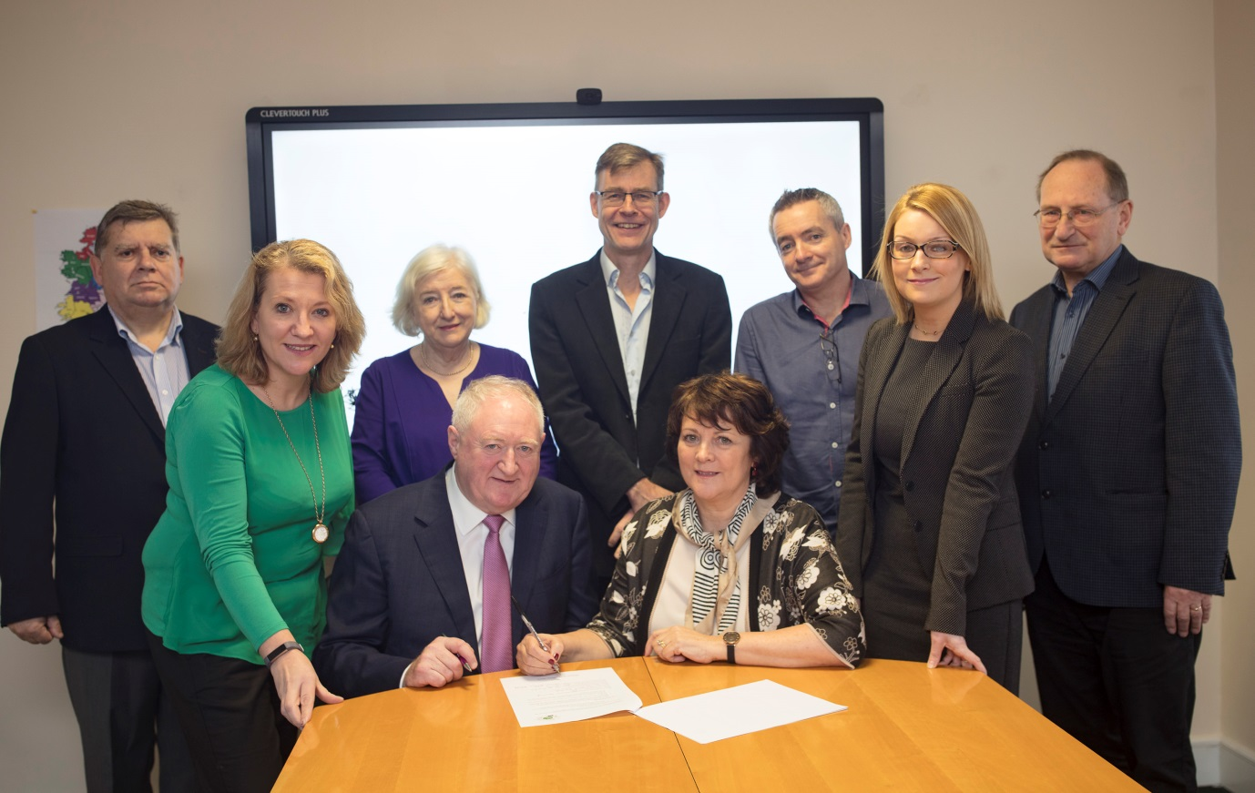
Age Sector NGO Alliance Members (L-R): Tom Costello (NGO Alliance Chair), Sharon Foley (Irish Hospice Foundation), Máiréad Hayes (Irish Senior Citizens Parliament), Pat McLoughlin (Alzheimer Society), Sean Moynihan (ALONE), Aine Brady (Third Age), Paddy Connolly (Age Action), Karen Smyth (Age & Opportunity) and Maurice O’Connell (NGO Alliance Facilitator). Maureen Kavanagh (Active Retirement Ireland) not pictured.

Conclusion
In 2018 the Alliance, although expanding, consolidated its objectives, outcomes and agreed principles. An independent chair, Mr Tom Costello, has been engaged to assist us in our programme of work which will pivot around the five agreed dates the Alliance will meet throughout the year. We will continue to work in between those meetings, building on consensus already achieved and work toward our agreed targets and outcomes.
Partnership work between NGOs requires a lot of commitment and resources and the current CEOs and boards of the eight NGOs are committed to this way of working. We are also committed to communicate with the wider stakeholder group and work closely with the Department of Health and other departments.
The Alliance of Age Sector NGOs has agreed that work on the implementation of NPAS must continue to be a priority for 2019. The work started on the scorecard was put on hold late in 2018 to support the National Stakeholder Forum on the NPAS. This was to allow Government Departments and in particular the Department of Health, to give current updates on developments on the NPAS. The Alliance has agreed to produce a scorecard from these updates with a view to identifying the progress or lack of action on NPAS by Government Departments.
January 2019

Contacts
For further information with regard to the work of the Alliance please contact:
Grainne Loughran
Communications Officer
ALONE
Olympic House, Pleasants Street
Dublin 8.
Tel: 01 679 1032

Active Retirement Ireland  www.activeirl.ie | Age Action  www.ageaction.ie
Age & Opportunity  www.ageandopportunity.ie | ALONE  www.alone.ie
Alzheimer Society of Ireland  www.alzheimer.ie | Irish Hospice Foundation  www.hospicefoundation.ie
The Irish Senior Citizens Parliament  www.seniors.ie | Third Age Ireland  www.thirdageireland.ie

Collaboration and joint Alliance initiatives are also informed by considerations arising from the Independent Review Group report on the relationship between voluntary organisations and the HSE/DOH.

